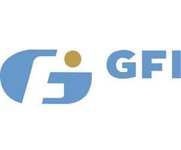
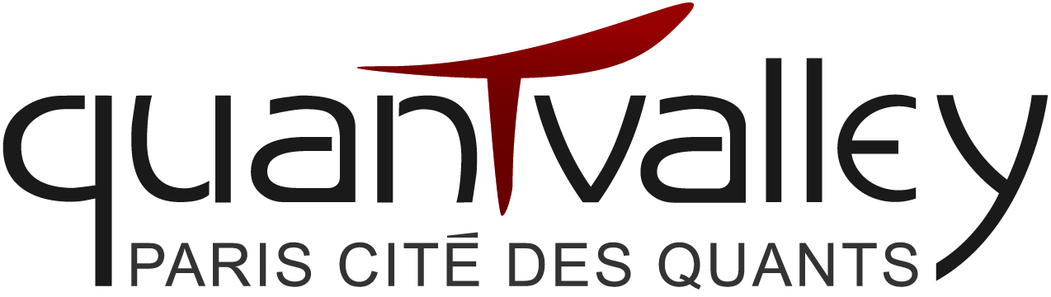
IdR QUANTVALLEY /FdR "Quantitative Management Initiative (QMI)"
CALL FOR RESEARCH PROJECTS
Deadline: June 20, 2013

Context
The Initiative de Recherche QUANTVALLEY/FdR "Quantitative Management Initiative (QMI)" was launched on February 1, 2012. It was created by two academic institutions, ENSAE (Ecole Nationale de la Statistique et de l’Administration Economique) and Université Paris Dauphine, with the view of developping a research program that addresses the use of quantitative tools and methods for asset management. It benefits from the support of three sponsors: QUANTVALLEY, GFI and UBS. See wwW.QMInitiative.org.
Objectives
The IdR QUANTVALLEY/FdR QMI is structured around the following objectives:
- Promoting quantitative research for asset management;
- Facilitating know-how transmission between academic researchers and asset managers;
- Promoting a positive image of quantitative-based asset management;
Topics
The organising committee invites submission of high-quality theoretical or empirical research projects about topics such as (but not necessarily limited to):
- Statistical signal processing
- Listed market liquidity
- Algo and/or high frequency trading
- Contagion and fund flows
- Risk disaggregation and portfolio allocation
- High order moments and portfolio allocation
- Machine learning and classification techniques with applications to trading systems
- Impact of quantitative trading on the economy
- New sources of information (Google, Twitter, …)
- Behavioral finance, heterogenous agents and portfolio optimization
- Macroeconomic analysis and financial markets behavior

Submission procedure
The deadline for paper project submission is June 20, 2013. All projects will be reviewed by the board of the IdR QUANTVALLEY/FdR QMI. The board will qualify a project as a Junior Project or a Senior Project based on its scope and the publication track record of the applicants in the field of the project.
Complete the enclosed form + join a resume for each application. These documents must be:
- in English in PDF format with a maximum size of 3MB;
- submitted by e-mail to: Fabrice.Riva@dauphine.fr
- marked "Paper project application – IdR QuantValley/FdR QMI".
Authors will be notified about the acceptance of their project by June 30, 2013. Accepted Junior Projects will be awarded €5,000 and accepted Senior Projects will be awarded €10,000. 50% will be paid one week after the notification of acceptance.
The final version of the paper should be sent by June 15, 2014 by email to: Fabrice.Riva@dauphine.fr. The remaining 50% will be paid at the final paper version acceptation.
The papers will be presented in the upcoming IdR QUANTVALLEY/FdR QMI annual conference during spring or summer 2014. Academics and practioners will be invited to participate in this conference. In addition to presenting their paper, the author(s) of the project commit(s) to mention in an acknowledgement section the following sentence : "The author(s) gratefully acknowledge(s) the support of the QUANTVALLEY/FdR: 'Quantitative Management Initiatve'".

Contact information

Fabrice Riva – +33 (0)1 44 05 49 88 – Fabrice.Riva@dauphine.fr
DRM Finance
Université Paris Dauphine
Place du Maréchal de Lattre de Tassigny
75775 Paris Cedex 16 - FRANCE

IdR QUANTVALLEY /FdR "Quantitative Management Initiative (QMI)"
Application Form
Deadline: June 15, 2013
1. The person in charge of the project
- Last name:
- First name:
- Position:
- University:
- Research center:
2. Project team members
Team members | Expertise / skills
- Last name:
- First name:
- Position:
- University:
- Research center:

- Last name:
- First name:
- Position:
- University:
- Research center:
3. Project team members (same format, one per page)
Member #1
A – Education
B – Academic experience
C – Publications
D – Honors & awards
4. Description of the project (including major milestones): max 5 pages

Initiative de Recherche (hereafter IdR) is the French expression for “Research Initiative”.

