Competition for the best digital poster of a doctoral thesis on the subject of the  Brazilian dictatorship of 1964-1985  (with a prize of 2,000 US$) | 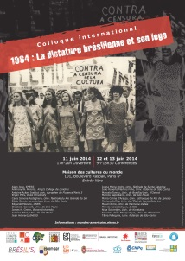

For a colloquium that will be held in Paris from the 11th to the 13th of June 2014, the Center for Research on Colonial and Contemporary Brazil (Ecole des Hautes Etudes and Sciences Sociales) has decided to organize a contest open to doctoral students who work on the Brazilian dictatorship of 1964, either directly or comparatively, independent of their discipline.

The candidates must send a digital poster describing their work to the organizers before June 1, 2014. The poster must be presented in a .doc or .docx format (Word or OpenOffice) and accompanied by a copy in .pdf form.

Features of the Document:

- Maximum length: 1000 words (including titles and subtitles)
- Number of documents: 3 maximum (images, tables, graphs, etc.). Any photographic documents used or produced by the participant must be under free license, or if they were downloaded from the internet, they must be accompanied by a link to the website from which they came.
- Video: a video of up to 3 minutes may accompany the poster. The video must have been uploaded to a hosting site such as Youtube or Vimeo and there should be a link to the video in the poster.
- Language: the digital poster can be in English, Spanish, French or Portuguese.

We will display the poster on the colloquium's blog (in Wordpress format) starting on June 2, 2014. The .pdf version will be available for download by any visitor on the colloquium's blog.

A prize of 2,000 US dollars will be awarded to the best poster by a vote of a jury made up of all the scholars who will give a talk or a comment in the colloquium. The ten best posters will be displayed by the websites of the CRBC and co-organizing universities for one year.

Candidates who would like to compete may sign up by completing the form which can be downloaded from the CRBC website in French, Portuguese, and English (http://crbc.ehess.fr/index.php?2042) and sending it to the address: brasil1964.poster@ehess.fr
Submission Deadline: June, 1 2014
Announcement of Results: June, 13 2014

The complete rules for the contest and the form can be downloaded from the CRBC website at http://crbc.ehess.fr/index.php?2042

