**[Institut de Recherche en Sciences de la Santé : IRSS](https://www.facebook.com/people/Institut-de-Recherche-en-Sciences-de-la-Sant%C3%A9-IRSS/100070928856303/?__cft__%5b0%5d=AZUGzr5DYPyp9L8gMCU3o3F-AFMZwMOHzxCpZlc_lleak35Er0grkOV9cpXzOZeSB4eVZ_1dvYfyQaeWiX7gA-jwPqf-mc_wBjhxnTVn5ahOFxBBg8F6NVGO_VCJawRt84P1BrRXpGdmBy2BSY3WN9Sznuk1rBZII6KJfHWpkSvzXA&__tn__=-UC%2CP-R)**

[**2d**](https://www.facebook.com/permalink.php?story_fbid=pfbid02ub7KtKcREz9oLj3CJJB92fbWf78SVxfP43rBQ4oR68fdHEi9bvYigzEZ5sCRenGSl&id=100070928856303&__cft__%5b0%5d=AZUGzr5DYPyp9L8gMCU3o3F-AFMZwMOHzxCpZlc_lleak35Er0grkOV9cpXzOZeSB4eVZ_1dvYfyQaeWiX7gA-jwPqf-mc_wBjhxnTVn5ahOFxBBg8F6NVGO_VCJawRt84P1BrRXpGdmBy2BSY3WN9Sznuk1rBZII6KJfHWpkSvzXA&__tn__=%2CO%2CP-R) ·

Invitation à la huitième session de Sciences Afternoons de l'IRSS, le 𝐣𝐞𝐮𝐝𝐢 𝟎𝟐 𝐨𝐜𝐭𝐨𝐛𝐫𝐞 𝟐𝟎𝟐𝟓 𝐚̀ 𝟏𝟒 𝐡 dans la Salle de Conférence de l'[**#IRSS**](https://www.facebook.com/hashtag/irss?__eep__=6&__cft__%5b0%5d=AZUGzr5DYPyp9L8gMCU3o3F-AFMZwMOHzxCpZlc_lleak35Er0grkOV9cpXzOZeSB4eVZ_1dvYfyQaeWiX7gA-jwPqf-mc_wBjhxnTVn5ahOFxBBg8F6NVGO_VCJawRt84P1BrRXpGdmBy2BSY3WN9Sznuk1rBZII6KJfHWpkSvzXA&__tn__=*NK-R).

Thème : 𝐄𝐱𝐩𝐥𝐨𝐢𝐭𝐚𝐭𝐢𝐨𝐧 𝐦𝐢𝐧𝐢𝐞̀𝐫𝐞 𝐚𝐫𝐭𝐢𝐬𝐚𝐧𝐚𝐥𝐞 𝐞𝐭 𝐬𝐚𝐧𝐭𝐞́ 𝐦𝐚𝐭𝐞𝐫𝐧𝐞𝐥𝐥𝐞 𝐞𝐭 𝐢𝐧𝐟𝐚𝐧𝐭𝐢𝐥𝐞 𝐚𝐮 𝐁𝐮𝐫𝐤𝐢𝐧𝐚 𝐅𝐚𝐬𝐨.

Participez via le lien :

[**https://us06web.zoom.us/j/89007835506...**](https://us06web.zoom.us/j/89007835506?pwd=SRQabBhFMaApEYGDnYM80lRLF8W6WO.1)

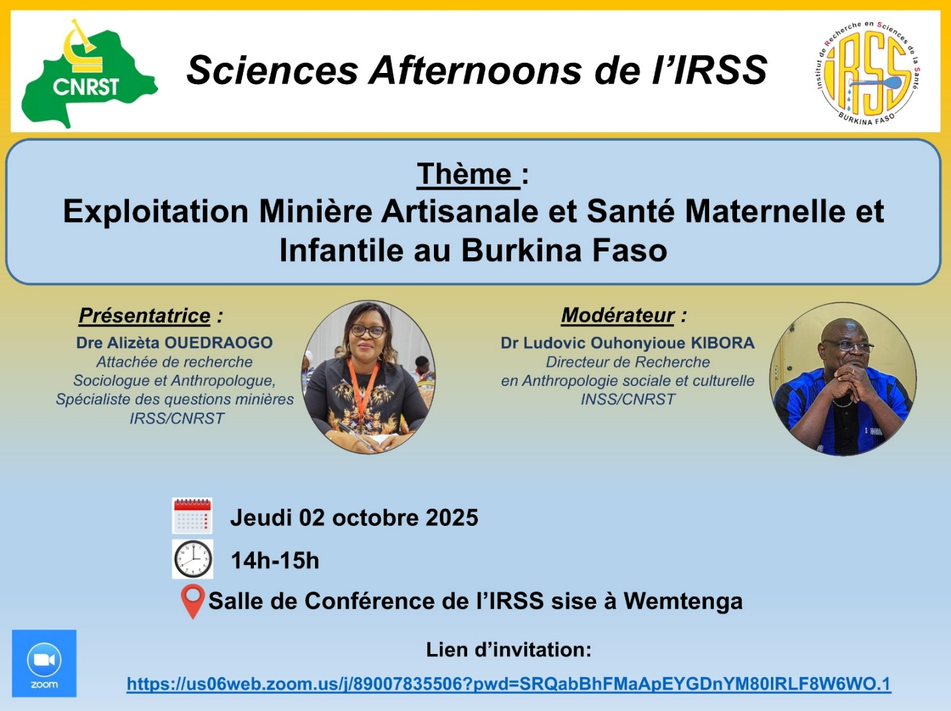

h

